
BSAI-3B
Artificial Intelligence (Lab)
Week-3 (tasks)
- Trace BFS and DFS manually:
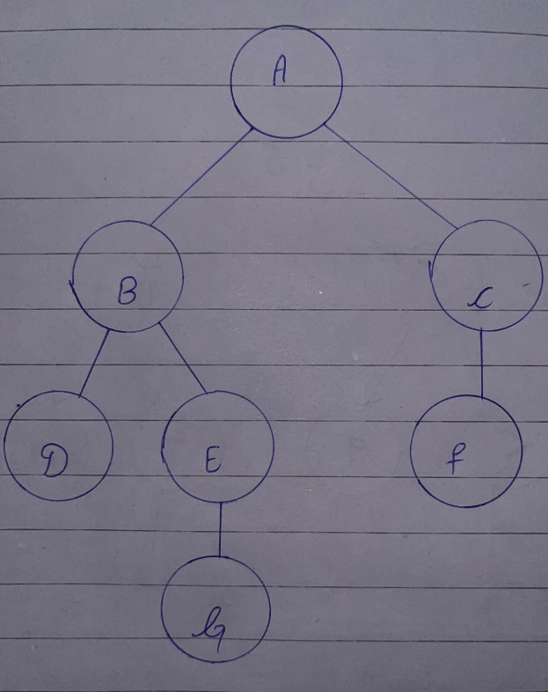

- Manual BFS Trace:

Processed Nodes | Queue (after processing) | Path
A | B, C | A
B | C, D, E | A B
C | D, E, F | A C
D | E, F | A B D
E | F, G | A B E
F | G | A C F
G | Empty | A B E G

- BFS results:
- Visit Order: A → B → C → D → E → F → G
- Final Path: A → B → E → G

- Manual DFS Trace:
Processed Nodes | Stack (after processing) | Path
A | C, B | A
B | C, E, D | A → B
D | C, E | A → B → D
E | C, G | A → B → E
G | Empty | A → B → E → G

- Notice that C is never processed because the algorithm finds G before returning to that branch.
- DFS final Results:
- Visit Order: A → B → D → E → G
- Final Path: A → B → E → G
- The Output of BFS/DFS code is:
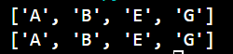

- Implement DLS and IDDFS:
- DLA results:

Depth Limit | Status | Final Path | Explanation
1 | CUTOFF | None | B and C have children below the depth limit.
2 | CUTOFF | None | E has child G at depth 3, beyond the limit.
3 | FOUND | A → B → E → G | Goal G is reached at depth 3.
4 | FOUND | A → B → E → G | Goal G is reached before the search reaches depth 4.

- IDDFS results:
- IDDFS repeatedly executes DLS, starting from depth 0 and increasing the limit by one.

Maximum depth | Status | Final Path | Limits Attempted
1 | CUTOFF | None | 0, 1
2 | CUTOFF | None | 0, 1, 2
3 | FOUND | A → B → E → G | 0, 1, 2, 3
4 | FOUND | A → B → E → G | 0, 1, 2, 3

- When the maximum depth is 4, IDDFS does not attempt depth 4 because the goal is found at depth 3 and the algorithm stops.

- Why Limits Below 3 Do Not Succeed:

- The shortest path from A to G is (A → B → E → G).
- The depth of each node along this path is:

Node | Depth
A | 0
B | 1
E | 2
G | 3

- Therefore, the goal is at depth 3.
- At limit 1, the search cannot reach E.
- At limit 2, the search reaches E but cannot explore G
- At limit 3, the search can reach and process G.

- Why IDDFS Repeats Work:

Node | Limit 1 | Limit 2 | Limit 3 | Limit 4
A | Explored | Explored | Explored | Explored
B |  | Explored | Explored | Explored
D |  |  | Explored | Explored
E |  |  | Explored | Explored
G |  |  |  | Explored

- The root A is explored in every iteration. B is explored in every iteration from limit 1 onward. This repeated work is intentional. IDDFS combines the low memory usage of DFS with the ability to find the shallowest solution.

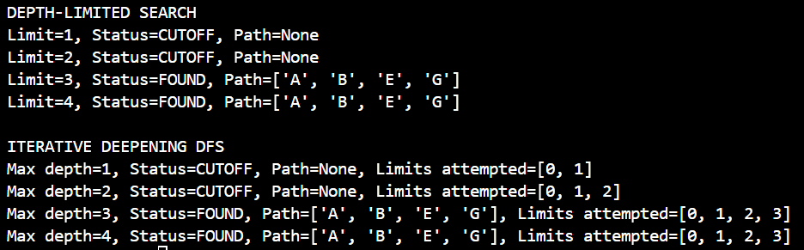
- The Output of the program is given as:

- Uniform Cost Search:
- UCS processing order:

Node Processed | Cost | Frontier after expansion
A | 0 | B (1), C (6)
B | 1 | E (2), D (3), C (6)
E | 2 | D (3), G (3), C (6)
D | 3 | G (3), C (6)
G | 3 | C (6)

- Processing order: A → B → E → D → G
- UCS returns: A → B → E → G
- Path Cost: 1+1+1 = 3

- Compare with BFS:
Algorithm | Returned Path | Number of Edges | Total Cost
BFS | A → C → G | 2 | 6+6 = 12
UCS | A → B → E → G | 3 | 1+1+1 = 3

- Why can a shorter-hop route cost more?
- BFS considers the number of edges. It finds the path with the fewest steps, but it does not account for the weight of each edge.
- UCS considers the accumulated cost of the entire path. In this graph, the two-edge route through C costs 12, while the three-edge route through B and E costs only 3.
- Therefore, the route with fewer hops is not necessarily the route with the lowest cost. UCS finds the minimum-cost route because it prioritizes accumulated edge weights rather than the number of edges.

